CSE 5523 HW 3

Lilong Jiang (jiang.573)

1. Problem 1

I use a HoldOut method for cross validation. 90% of training dataset is for training, 10% of training dataset is to calculate training error.

Bagged_10 means there are 10 number of trees.

Boosted_100 means 100 ensemble learning cycles.

|  |  |  |  |  |  |  |  |  |
| --- | --- | --- | --- | --- | --- | --- | --- | --- |
|  | Decision | Bagged_10 | Bagged_15 | Bagged_20 | Boosted_50 | Boosted_100 | Boosted_150 | Boosted_200 |
| Training Error | 0.0550 | 0.0600 | 0.0300 | 0.0200 | 0.0600 | 0.0350 | 0.0300 | 0.0350 |
| Testing Error | 0.0475 | 0.0350 | 0.0210 | 0.0245 | 0.0615 | 0.0505 | 0.0495 | 0.0435 |

Usually, as the increase of number of tree increases or number of learning cycles, both training error and testing error will decrease and better than decision tree.

**Decision Tree Code:**

Y = [ones(1000, 1); -ones(1000, 1)];

load('train79.mat');

trainData = d79;

load('test79.mat');

testData = d79;

N = size(trainData, 1);

M = size(trainData, 2);

percent = 0.1;

[TrainInd, TestInd] = crossvalind(N, percent);

trainTrainN = size(TrainInd, 1);

trainTestN = size(TestInd, 1);

trainTrainData = zeros(trainTrainN, M);

trainTrainYs = zeros(trainTrainN, 1);

trainTestData = zeros(trainTestN, M);

for i = 1: trainTrainN

trainTrainData(i, :) = trainData(TrainInd(i), :);

if TrainInd(i) <= 1000

trainTrainYs(i) = 1;

else

trainTrainYs(i) = -1;

end

end

for i = 1: trainTestN

trainTestData(i, :) = trainData(TestInd(i), :);

end

tree = fitctree(trainTrainData, trainTrainYs);

predTrainLabels = predict(tree, trainTestData);

trainError = 0;

for i = 1 : trainTestN

if TestInd(i) <= 1000

trueLabel = 1;

else

trueLabel = -1;

end

if predTrainLabels(i) ~= trueLabel

trainError = trainError + 1;

end

end

trainError = trainError / trainTestN

testN = size(testData, 1);

predTestLabels = predict(tree, testData);

testError = 0;

for i = 1: testN

if i <= 1000

trueLabel = 1;

else

trueLabel = -1;

end

if predTestLabels(i) ~= trueLabel

testError = testError + 1;

end

end

testError = testError / testN

**Bagged Tree Code:**

treeNum = 20;

B = TreeBagger(treeNum, trainTrainData, trainTrainYs);

predTrainLabels = predict(B, trainTestData);

trainError = 0;

for i = 1 : trainTestN

if TestInd(i) <= 1000

trueLabel = 1;

else

trueLabel = -1;

end

if str2double(predTrainLabels{i}) ~= trueLabel

trainError = trainError + 1;

end

end

trainError = trainError * 1.0 / trainTestN

testN = size(testData, 1);

predTestLabels = predict(B, testData);

testError = 0;

for i = 1: testN

if i <= 1000

trueLabel = 1;

else

trueLabel = -1;

end

if str2double(predTestLabels{i}) ~= trueLabel

testError = testError + 1;

end

end

testError = testError * 1.0 / testN

**Boosted Tree Code:**

ens = fitensemble(trainTrainData, trainTrainYs, 'AdaBoostM1', 200, 'Tree');

predTrainLabels = predict(ens, trainTestData);

trainError = 0;

for i = 1 : trainTestN

if TestInd(i) <= 1000

trueLabel = 1;

else

trueLabel = -1;

end

if predTrainLabels(i) ~= trueLabel

trainError = trainError + 1;

end

end

trainError = trainError * 1.0 / trainTestN

testN = size(testData, 1);

predTestLabels = predict(ens, testData);

testError = 0;

for i = 1: testN

if i <= 1000

trueLabel = 1;

else

trueLabel = -1;

end

if predTestLabels(i) ~= trueLabel

testError = testError + 1;

end

end

testError = testError * 1.0 / testN

1. Problem 2
2. The visualization figure is shown below. This is performed on the training data.

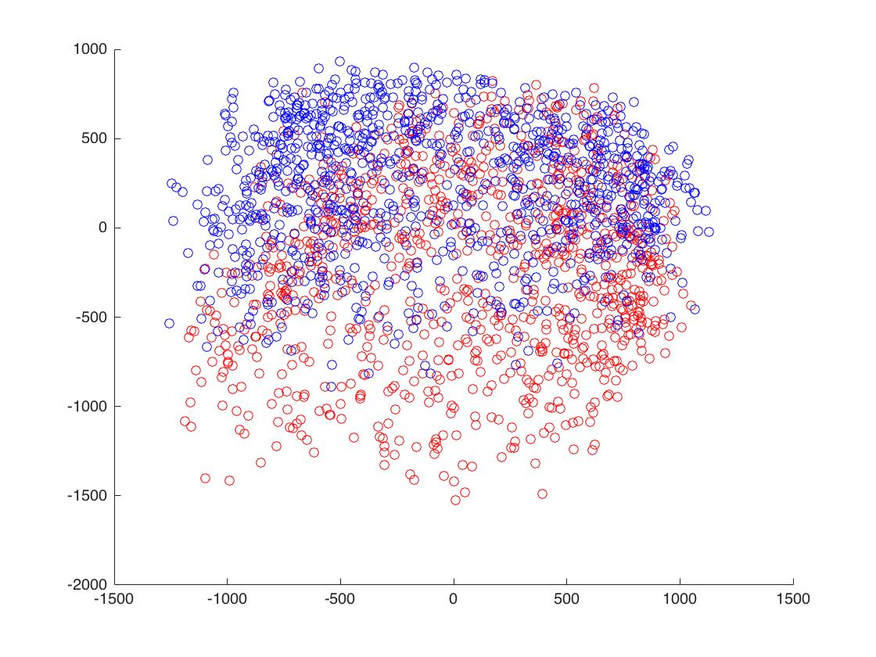

**Code is shown below:**

load('train79.mat');

trainData = d79;

trainData = bsxfun(@minus, trainData, mean(trainData, 1));

C = cov(trainData);

[V D] = eig(C);

[D order] = sort(diag(D), 'descend');

V = V(:, order);

trainData = trainData * V(:, 1: 2);

cdata = [ones(1000, 1) * [1 0 0]; ones(1000, 1) * [0 0 1]];

size(trainData)

scatter(trainData(:, 1), trainData(:, 2), 'o', 'cdata', cdata)

1. Figure of Class 7 is shown below. It seems that it captures two type of 7s in each figure.

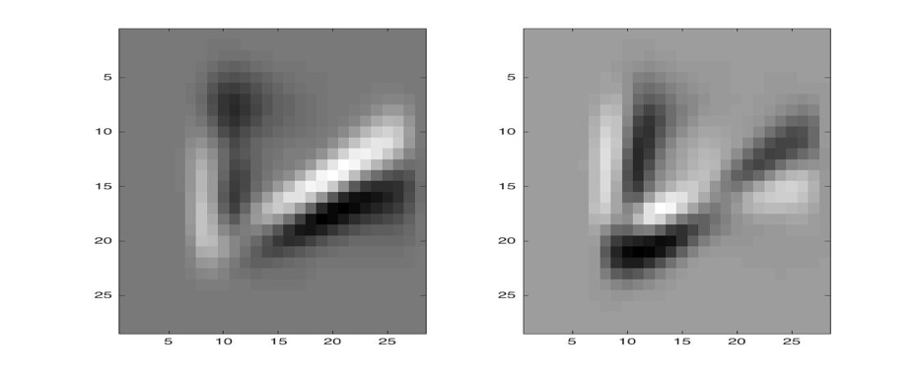

Figure of Class 9 is shown below. It seems that it captures two type of 9s in each figure.

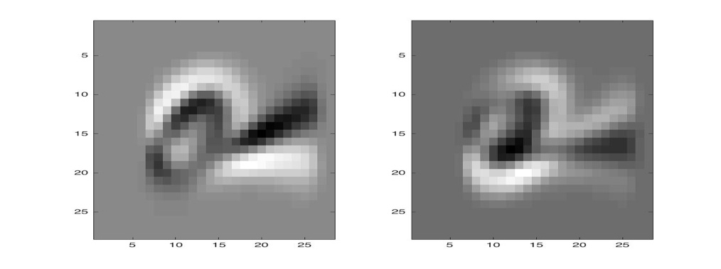

Figure of both classes are shown below. It seems the left figure captures 9 and another figure captures 7.

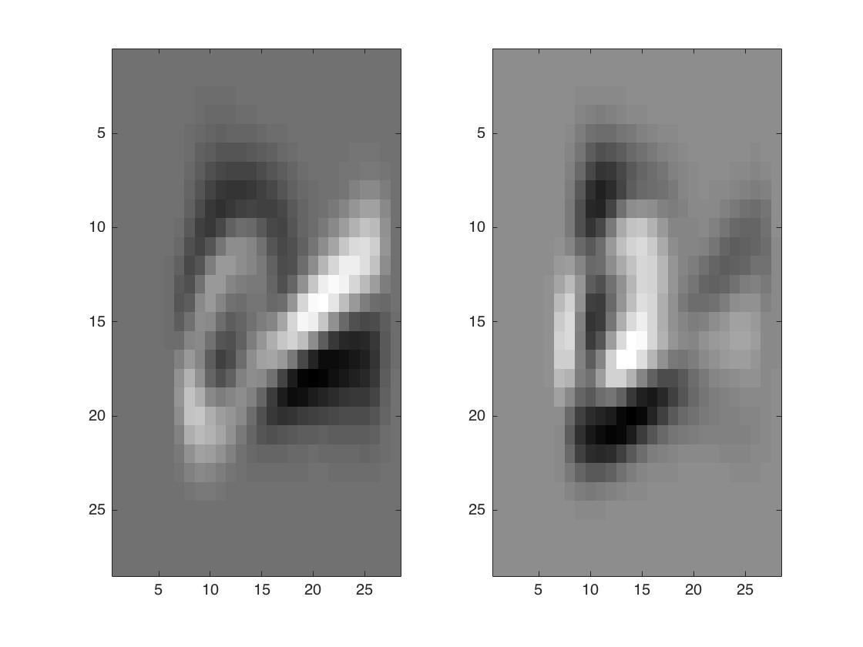

**Code is shown below:**

load('train79.mat');

trainData = d79;

load('test79.mat');

testData = d79;

X1 = [trainData(1: 1000, :); testData(1: 1000, :)];

X2 = [trainData(1001: 2000, :); testData(1001: 2000, :)];

X3 = [X1; X2];

X = X3;

X = X';

X = bsxfun(@minus, X, mean(X, 2));

s = cov(X');

[V, D] = eig(s);

[D order] = sort(diag(D), 'descend');

V = V(:, order);

figure,subplot(1, 2, 1)

colormap gray

for i = 1:2

subplot(1, 2, i)

imagesc(reshape(V(:, i), 28, 28))

end

1. Problem 3

I run clustering algorithms on test dataset.

The error rate is calculated in the following way, for the first 1000 images, I will pick up the largest cluster, all points out of the largest cluster is classified as error. The same for the later 1000 pages.

|  |  |  |  |  |
| --- | --- | --- | --- | --- |
|  | 2 | 5 | 10 | 50 |
| k-means | 0.3965 | 0.7400 | 0.7700 | 0.9325 |
| Single-linkage | 5.0000e-04 | 0.0020 | 0.0050 | 0.0260 |

**Code for K-means:**

load('test79.mat');

testData = d79;

ks = [2, 5, 10, 50];

for kIdx = 1: size(ks, 2)

error = 0;

k = ks(kIdx);

clusterLabels = kmeans(testData, k);

clusterNums = zeros(k, 1);

for i = 1: 1000

label = clusterLabels(i);

clusterNums(label) = clusterNums(label) + 1;

end

[maxVal, maxIdx] = max(clusterNums);

error = 1000 - maxVal;

clusterNums = zeros(k, 1);

for i = 1001: 2000

label = clusterLabels(i);

clusterNums(label) = clusterNums(label) + 1;

end

[maxVal, maxIdx] = max(clusterNums);

error = error + 1000 - maxVal;

error = error * 1.0 / 2000

end

**Code for single-linkage clustering:**

load('test79.mat');

testData = d79;

distMat = pdist(testData);

Z = linkage(distMat, 'single');

% dendrogram(Z)

ks = [2, 5, 10, 50];

for kIdx = 1: size(ks, 2)

error = 0;

k = ks(kIdx);

clusterLabels = cluster(Z,'maxclust', k) ;

clusterNums = zeros(k, 1);

for i = 1: 1000

label = clusterLabels(i);

clusterNums(label) = clusterNums(label) + 1;

end

[maxVal, maxIdx] = max(clusterNums);

error = 1000 - maxVal;

clusterNums = zeros(k, 1);

for i = 1001: 2000

label = clusterLabels(i);

clusterNums(label) = clusterNums(label) + 1;

end

[maxVal, maxIdx] = max(clusterNums);

error = error + 1000 - maxVal;

error = error * 1.0 / 2000

end